VACUUM TUBE MANUFACTURING PLAN

1. ACQUIRE:
   1. 2” OD Delrin Tube
   2. 3/16” endmill (at least .26” long)
   3. Center Drill
   4. ½ - 1” endmill
   5. Vice Swivel or rotary table
      1. Most mills will have a Kurt style vice (they’re nice because the jaw doesn’t lift up much) and with this you’ll usually find a vice swivel base for at least one of them in a shop. This is designed to clamp the vice at an angle in the table. Skip to 2 if you have this, if not continue reading

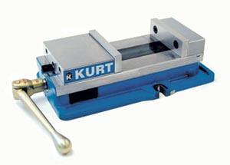+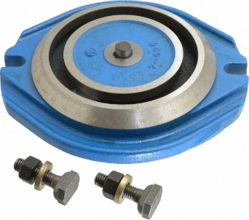=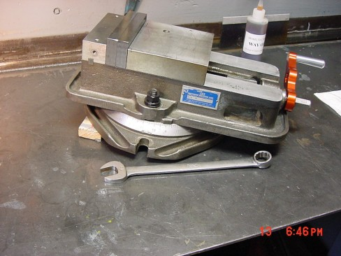

If a mill has this setup it will be the quickest to do this part with. If not you can use a rotary table. A rotary table is a table that you can mount onto a mill that gives you a rotational axis, this is how you can make circles. These are heavy, have someone help you lift it onto the mill. Clamp with T Nuts. Then clamp the vice onto it.

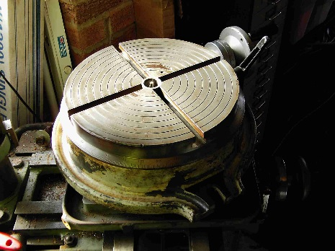+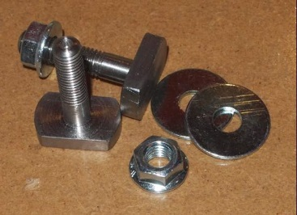=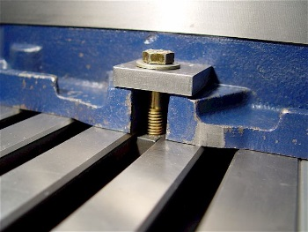

Since you just stuck this on your vice base is orthogonal to the spindle (you did clean the table off well first right and checked for chips sticking to the bottom of things??!?) but you have no idea where the fixed vice jaw is relative to the mills X axis. Acquire an indicator. Be carefule these are delicate and at first you’ll be way out of square so it’ll be easy to force it past its range. Basically you need to put it in the spindle, lock the spindle so it doesn’t rotate (either put it in back gear or set the brake {you can push the brake lever right, well its like a cam so if you pull it a little you can lock it} now with the spindle NOT free to rotate you can put this guy in the right orientation and start traming out the FIXED vice jaw. Get this within 0.02” over 6” or so (error here will alter the 45degrees)

So now we have a vice in a rotarty table square to the mills X axis right? Good.

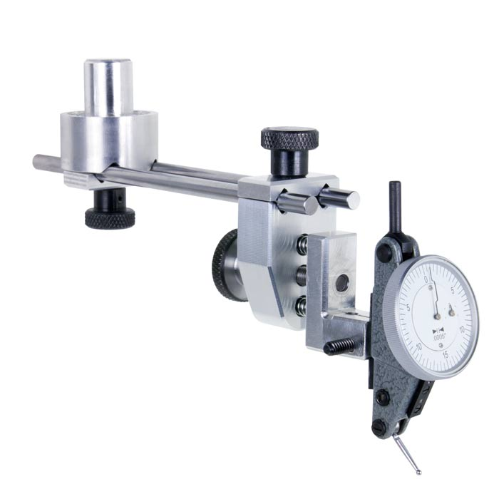🡪 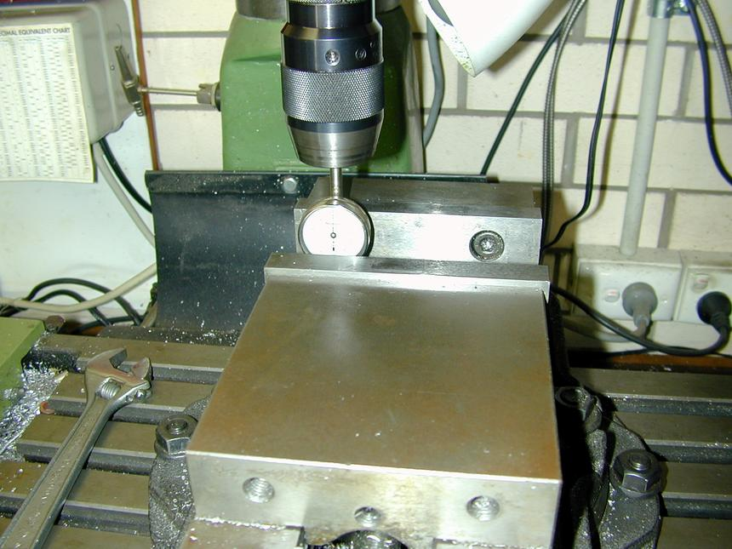

1. Clamp tube in vice. This tube wall is thin – aka it will bend, distort ant break easily. I’m pretty sure it will fit in the vice ok, you need a minimum of 3/8” sticking above the vice jaws. Clamp it to what you think you can, try to rotate it by hand when you do just to get a feel for how well it’s clamped. These are small cuts so the forces shouln’t be terrible but it’s hard to gauge without being there.
2. Find top of tube: Now get a sharpie and ink up the top area of the tube about 1.1” away from an end. Now put a larger (~.5”) end mill into the mill (with a collet {Drill chucks are not designed for sideways forces}). Now get a caliper and set it to 1.14”, this is the distance from the top end to the center of the first slot. Scribe this onto the top of the tube, you’ll be able to see it easily since its being scribed into the sharpied area. Now move said endmill over this area and slowly bring the Knee up until it just skims the top surface (with it spinning {wait you remembered to take the brake off right?}, if you have the touch you can just swipe off the sharpie and not remove and plastic. Now you have a cross hairs for where the center point of this first slot is.
3. Move angle of tube to 45 degrees with rotary table/vice swivel.
4. Acquire a center drill, put into mill, locate the cross hair you just made with this. You should be able to locate it to within ~0.01” pretty easially. If its off a little it wont kill anything. Lock the x an Y axis at this point and zero your DRO
5. Put in the 3/16” end mill, make sure the corners aren’t chipped first, students like to drop endmills make sure you have at least .26 “ exposed. If possible don’t have like 2” exposed…. Endmills this small aren’t that rigid….. Also for the love of god use a collet for this, not a drill chuck.
6. Make first slot, you should be able to do this by just moving the Y axis and the knee (lock the spindle Z axis for good measure) With a endmill this small the suggested SFM will probably be higher your mill can spin so do what you can…. Start with a shallow depth of cut (~.03in) to be safe since it isn’t clamped very well. Change as necessary from feel.
7. Mill slot until you reach the depth in the drawing.
8. Move to next slot, move X axis 0.530”. Check that it looks right and that I’m not confused with the slot angle since its late right now. The slot gap to material between slots should be about equal (both 3/16” wide)
9. Cut all slots
10. Clean up all the plastic mess you got everywhere.